Statistical Distributions

By

Bill Young

Contents

Tests 4

Shapiro-Wilk Normality Test 4

Kolmogorov-Smirnov 4

General Information 4

Discrete Distributions 4

Definition: 4

With Finite Support 4

With Infinite Support 5

Continuous Distributions 6

Definition: 6

Supported On A Bounded Interval 6

Supported On Intervals Of Length 2π – Directional Distributions 12

[Supported On Semi-infinite Intervals, Usually 0,∞) 17

Supported On The Whole Real Line 18

With Variable Support 20

Mixed Discrete/Continuous Distributions 20

Joint Distributions 20

Two or More Random Variables On The Sample Space 20

Matrix-Valued Distributions 21

Non-numeric Distributions 21

Miscellaneous Distributions 21

Works Cited 22

# Tests

## Shapiro-Wilk Normality Test

(Zaiontz, Shapiro-Wilk Original Test) (Zaiontz, Shapiro-Wilk Expanded Test)

## Kolmogorov-Smirnov

(Sonnier)

# General Information

Common Probability Distributions (Joyce, 2016)

# Discrete Distributions

## Definition:

“A [statistical distribution](http://mathworld.wolfram.com/StatisticalDistribution.html) whose variables can take on only discrete values. Abramowitz and Stegun (1972, p. 929) give a table of the parameters of most common discrete distributions.” (Weisstein, Discrete Distribution, 2017)

## With Finite Support

* The [Bernoulli distribution](https://en.wikipedia.org/wiki/Bernoulli_distribution), which takes value 1 with probability *p* and value 0 with probability *q* = 1 − *p*.
* [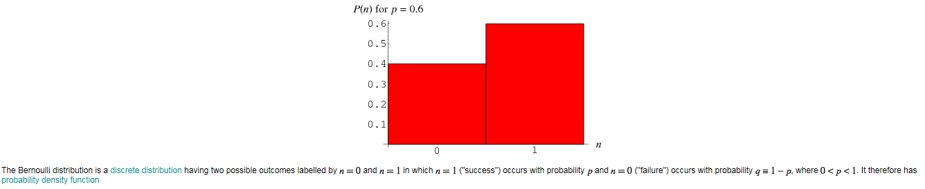](https://github.com/Temtesb/StatisticsCalculationsForExcel/blob/master/Documentation/Images/BernoulliDistribution.png) (Weisstein, Wolfram Mathworld, 2017)
* The [Rademacher distribution](https://en.wikipedia.org/wiki/Rademacher_distribution), which takes value 1 with probability 1/2 and value −1 with probability 1/2.
* The [binomial distribution](https://en.wikipedia.org/wiki/Binomial_distribution), which describes the number of successes in a series of independent Yes/No experiments all with the same probability of success.
* The [beta-binomial distribution](https://en.wikipedia.org/wiki/Beta-binomial_model), which describes the number of successes in a series of independent Yes/No experiments with heterogeneity in the success probability.
* The [degenerate distribution](https://en.wikipedia.org/wiki/Degenerate_distribution) at *x*0, where *X* is certain to take the value *x*0. This does not look random, but it satisfies the definition of [random variable](https://en.wikipedia.org/wiki/Random_variable). This is useful because it puts deterministic variables and random variables in the same formalism.
* The [discrete uniform distribution](https://en.wikipedia.org/wiki/Uniform_distribution_(discrete)), where all elements of a finite [set](https://en.wikipedia.org/wiki/Set_theory) are equally likely. This is the theoretical distribution model for a balanced coin, an unbiased die, a casino roulette, or the first card of a well-shuffled deck.
* The [hypergeometric distribution](https://en.wikipedia.org/wiki/Hypergeometric_distribution), which describes the number of successes in the first *m* of a series of *n* consecutive Yes/No experiments, if the total number of successes is known. This distribution arises when there is no replacement.
* The [Poisson binomial distribution](https://en.wikipedia.org/wiki/Poisson_binomial_distribution), which describes the number of successes in a series of independent Yes/No experiments with different success probabilities.
* [Fisher's noncentral hypergeometric distribution](https://en.wikipedia.org/wiki/Fisher%27s_noncentral_hypergeometric_distribution)
* [Wallenius' noncentral hypergeometric distribution](https://en.wikipedia.org/wiki/Wallenius%27_noncentral_hypergeometric_distribution)
* [Benford's law](https://en.wikipedia.org/wiki/Benford%27s_law), which describes the frequency of the first digit of many naturally occurring data.

## With Infinite Support

* The [beta negative binomial distribution](https://en.wikipedia.org/wiki/Beta_negative_binomial_distribution)
* The [Boltzmann distribution](https://en.wikipedia.org/wiki/Boltzmann_distribution), a discrete distribution important in [statistical physics](https://en.wikipedia.org/wiki/Statistical_physics) which describes the probabilities of the various discrete energy levels of a system in [thermal equilibrium](https://en.wikipedia.org/wiki/Thermal_equilibrium). It has a continuous analogue. Special cases include:
  + The [Gibbs distribution](https://en.wikipedia.org/wiki/Gibbs_distribution)
  + The [Maxwell–Boltzmann distribution](https://en.wikipedia.org/wiki/Maxwell%E2%80%93Boltzmann_distribution)
* The [Borel distribution](https://en.wikipedia.org/wiki/Borel_distribution)
* The [Champernowne distribution](https://en.wikipedia.org/wiki/Champernowne_distribution)
* The [extended negative binomial distribution](https://en.wikipedia.org/wiki/Extended_negative_binomial_distribution)
* The [extended hypergeometric distribution](https://en.wikipedia.org/wiki/Extended_hypergeometric_distribution)
* The [generalized log-series distribution](https://en.wikipedia.org/w/index.php?title=Generalized_log-series_distribution&action=edit&redlink=1)
* The [geometric distribution](https://en.wikipedia.org/wiki/Geometric_distribution), a discrete distribution which describes the number of attempts needed to get the first success in a series of independent Bernoulli trials, or alternatively only the number of losses before the first success (i.e. one less).
* The [logarithmic (series) distribution](https://en.wikipedia.org/wiki/Logarithmic_distribution)
* The [negative binomial distribution](https://en.wikipedia.org/wiki/Negative_binomial_distribution) or Pascal distribution a generalization of the geometric distribution to the *n*th success.
* The discrete [compound Poisson distribution](https://en.wikipedia.org/wiki/Compound_Poisson_distribution)
* The [parabolic fractal distribution](https://en.wikipedia.org/wiki/Parabolic_fractal_distribution)
* The [Poisson distribution](https://en.wikipedia.org/wiki/Poisson_distribution), which describes a very large number of individually unlikely events that happen in a certain time interval. Related to this distribution are a number of other distributions: the [displaced Poisson](https://en.wikipedia.org/wiki/Displaced_Poisson_distribution), the hyper-Poisson, the general Poisson binomial and the Poisson type distributions.
  + The [Conway–Maxwell–Poisson distribution](https://en.wikipedia.org/wiki/Conway%E2%80%93Maxwell%E2%80%93Poisson_distribution), a two-parameter extension of the [Poisson distribution](https://en.wikipedia.org/wiki/Poisson_distribution) with an adjustable rate of decay.
  + The [Zero-truncated Poisson distribution](https://en.wikipedia.org/wiki/Zero-truncated_Poisson_distribution), for processes in which zero counts are not observed
* The [Polya–Eggenberger distribution](https://en.wikipedia.org/w/index.php?title=Polya%E2%80%93Eggenberger_distribution&action=edit&redlink=1)
* The [Skellam distribution](https://en.wikipedia.org/wiki/Skellam_distribution), the distribution of the difference between two independent Poisson-distributed random variables.
* The [skew elliptical distribution](https://en.wikipedia.org/w/index.php?title=Skew_elliptical_distribution&action=edit&redlink=1)
* The [Yule–Simon distribution](https://en.wikipedia.org/wiki/Yule%E2%80%93Simon_distribution)
* The [zeta distribution](https://en.wikipedia.org/wiki/Zeta_distribution) has uses in applied statistics and statistical mechanics, and perhaps may be of interest to number theorists. It is the [Zipf distribution](https://en.wikipedia.org/wiki/Zipf_distribution) for an infinite number of elements.
* [Zipf's law](https://en.wikipedia.org/wiki/Zipf%27s_law) or the Zipf distribution. A discrete [power-law](https://en.wikipedia.org/wiki/Power_law) distribution, the most famous example of which is the description of the frequency of words in the English language.
* The [Zipf–Mandelbrot law](https://en.wikipedia.org/wiki/Zipf%E2%80%93Mandelbrot_law) is a discrete power law distribution which is a generalization of the [Zipf distribution](https://en.wikipedia.org/wiki/Zipf_distribution).

# Continuous Distributions

## Definition:

A continuous random variable is a random variable with a set of possible values (known as the range or support) that is infinite and uncountable. Probabilities of continuous random variables (X) are defined as the area under the curve of its distribution. Thus, only ranges of values can have a nonzero probability. (Minitab)

## Supported On A Bounded Interval

* The [arcsine distribution](https://en.wikipedia.org/wiki/Arcsine_distribution) on [*a*,*b*], which is a special case of the Beta distribution if *a* = 0 and *b* = 1.
* The [Beta distribution](https://en.wikipedia.org/wiki/Beta_distribution) on [0,1], a family of two-parameter distributions with one mode, of which the uniform distribution is a special case, and which is useful in estimating success probabilities.
* The [logitnormal distribution](https://en.wikipedia.org/wiki/Logitnormal) on (0,1).
* 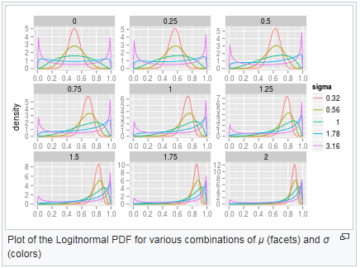 (Wikipedia)
* The [Dirac delta function](https://en.wikipedia.org/wiki/Dirac_delta_function) although not strictly a function, is a limiting form of many continuous probability functions. It represents a *discrete* probability distribution concentrated at 0 — a [degenerate distribution](https://en.wikipedia.org/wiki/Degenerate_distribution) — but the notation treats it as if it were a continuous distribution.
* The [continuous uniform distribution](https://en.wikipedia.org/wiki/Uniform_distribution_(continuous)) or [rectangular distribution](https://en.wikipedia.org/wiki/Rectangular_distribution) on [*a*,*b*], where all points in a finite interval are equally likely.
* 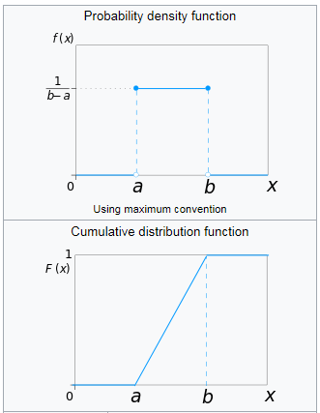 (Wikipedia)
* The [Irwin–Hall distribution](https://en.wikipedia.org/wiki/Irwin%E2%80%93Hall_distribution) is the distribution of the sum of *n* i.i.d. U(0,1) random variables.
* 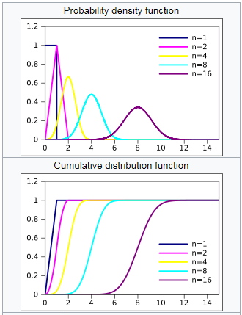 (Wikipedia)
* The [Bates distribution](https://en.wikipedia.org/wiki/Bates_distribution) is the distribution of the mean of *n* i.i.d. U(0,1) random variables.
* The [Kent distribution](https://en.wikipedia.org/wiki/Kent_distribution) on the three-dimensional sphere.
* 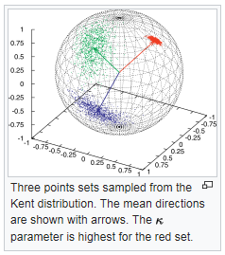 (Wikipedia)
* The [Kumaraswamy distribution](https://en.wikipedia.org/wiki/Kumaraswamy_distribution) is as versatile as the Beta distribution but has simple closed forms for both the cdf and the pdf.
* 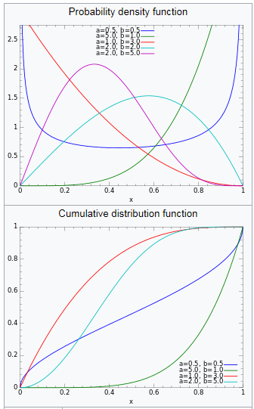 (Wikipedia)
* The [logarithmic distribution (continuous)](https://en.wikipedia.org/w/index.php?title=Logarithmic_distribution_(continuous)&action=edit&redlink=1)
* The [Marchenko–Pastur distribution](https://en.wikipedia.org/wiki/Marchenko%E2%80%93Pastur_distribution) is important in the theory of [random matrices](https://en.wikipedia.org/wiki/Random_matrices).
* The PERT distribution is a special case of the [beta distribution](https://en.wikipedia.org/wiki/Beta_distribution)
* The [raised cosine distribution](https://en.wikipedia.org/wiki/Raised_cosine_distribution)
* 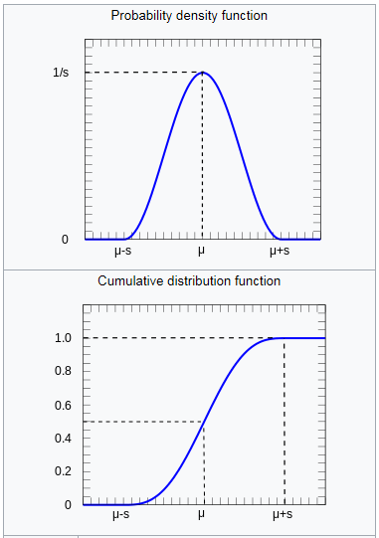 (Wikipedia)
* The [reciprocal distribution](https://en.wikipedia.org/wiki/Reciprocal_distribution)
* The [triangular distribution](https://en.wikipedia.org/wiki/Triangular_distribution) on [*a*, *b*], a special case of which is the distribution of the sum of two independent uniformly distributed random variables (the *convolution* of two uniform distributions).
* 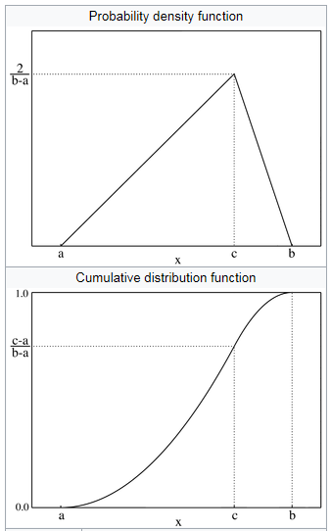 (Wikipedia)
* The [trapezoidal distribution](https://en.wikipedia.org/wiki/Trapezoidal_distribution)
* The [truncated normal distribution](https://en.wikipedia.org/wiki/Truncated_normal_distribution) on [*a*, *b*].
* The [U-quadratic distribution](https://en.wikipedia.org/wiki/U-quadratic_distribution) on [*a*, *b*].
* The [von Mises-Fisher distribution](https://en.wikipedia.org/wiki/Von_Mises-Fisher_distribution) on the *N*-dimensional sphere has the [von Mises distribution](https://en.wikipedia.org/wiki/Von_Mises_distribution) as a special case.
* The [Wigner semicircle distribution](https://en.wikipedia.org/wiki/Wigner_semicircle_distribution) is important in the theory of [random matrices](https://en.wikipedia.org/wiki/Random_matrices).

## Supported On Intervals Of Length 2π – Directional Distributions

* The [von Mises distribution](https://en.wikipedia.org/wiki/Von_Mises_distribution)
* 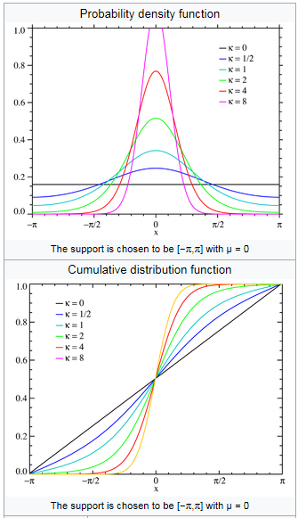 (Wikipedia)
* The [wrapped normal distribution](https://en.wikipedia.org/wiki/Wrapped_normal_distribution)
* 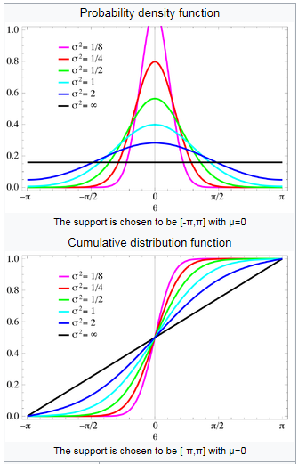 (Wikipedia)
* The [wrapped exponential distribution](https://en.wikipedia.org/wiki/Wrapped_exponential_distribution)
* 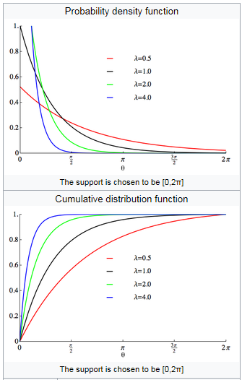 (Wikipedia)
* The [wrapped Lévy distribution](https://en.wikipedia.org/wiki/Wrapped_L%C3%A9vy_distribution)
* The [wrapped Cauchy distribution](https://en.wikipedia.org/wiki/Wrapped_Cauchy_distribution)
* 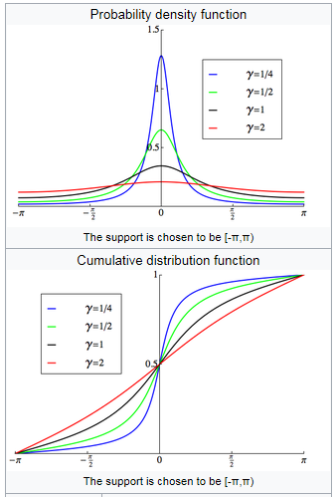 (Wikipedia)
* The [wrapped Laplace distribution](https://en.wikipedia.org/wiki/Wrapped_Laplace_distribution)
* The [wrapped asymmetric Laplace distribution](https://en.wikipedia.org/wiki/Wrapped_asymmetric_Laplace_distribution)
* 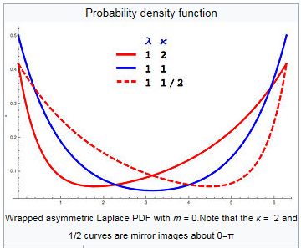 (Wikipedia)
* The [Dirac comb](https://en.wikipedia.org/wiki/Dirac_comb) of period 2 π although not strictly a function, is a limiting form of many directional distributions. It is essentially a wrapped [Dirac delta function](https://en.wikipedia.org/wiki/Dirac_delta_function). It represents a *discrete* probability distribution concentrated at 2πn — a [degenerate distribution](https://en.wikipedia.org/wiki/Degenerate_distribution) — but the notation treats it as if it were a continuous distribution.
* 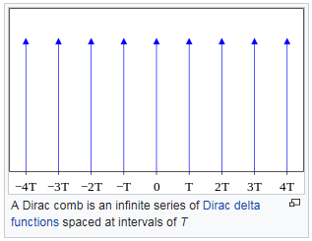 (Wikipedia)

## Supported On Semi-infinite Intervals, Usually [0,∞)

* The [Beta prime distribution](https://en.wikipedia.org/wiki/Beta_prime_distribution)
* The [Birnbaum–Saunders distribution](https://en.wikipedia.org/wiki/Birnbaum%E2%80%93Saunders_distribution), also known as the fatigue life distribution, is a probability distribution used extensively in reliability applications to model failure times.
* The [chi distribution](https://en.wikipedia.org/wiki/Chi_distribution)
  + The [noncentral chi distribution](https://en.wikipedia.org/wiki/Noncentral_chi_distribution)
* The [chi-squared distribution](https://en.wikipedia.org/wiki/Chi-squared_distribution), which is the sum of the squares of *n* independent Gaussian random variables. It is a special case of the Gamma distribution, and it is used in [goodness-of-fit](https://en.wikipedia.org/wiki/Goodness-of-fit) tests in [statistics](https://en.wikipedia.org/wiki/Statistics).
  + The [inverse-chi-squared distribution](https://en.wikipedia.org/wiki/Inverse-chi-squared_distribution)
  + The [noncentral chi-squared distribution](https://en.wikipedia.org/wiki/Noncentral_chi-squared_distribution)
  + The [Scaled-inverse-chi-squared distribution](https://en.wikipedia.org/wiki/Scaled-inverse-chi-squared_distribution)
* The [Dagum distribution](https://en.wikipedia.org/wiki/Dagum_distribution)
* The [exponential distribution](https://en.wikipedia.org/wiki/Exponential_distribution), which describes the time between consecutive rare random events in a process with no memory.
* The [Exponential-logarithmic distribution](https://en.wikipedia.org/wiki/Exponential-logarithmic_distribution)
* The [F-distribution](https://en.wikipedia.org/wiki/F-distribution), which is the distribution of the ratio of two (normalized) chi-squared-distributed random variables, used in the [analysis of variance](https://en.wikipedia.org/wiki/Analysis_of_variance). It is referred to as the [beta prime distribution](https://en.wikipedia.org/wiki/Beta_prime_distribution) when it is the ratio of two chi-squared variates which are not normalized by dividing them by their numbers of degrees of freedom.
  + The [noncentral F-distribution](https://en.wikipedia.org/wiki/Noncentral_F-distribution)
* [Fisher's z-distribution](https://en.wikipedia.org/wiki/Fisher%27s_z-distribution)
* The [folded normal distribution](https://en.wikipedia.org/wiki/Folded_normal_distribution)
* The [Fréchet distribution](https://en.wikipedia.org/wiki/Fr%C3%A9chet_distribution)
* The [Gamma distribution](https://en.wikipedia.org/wiki/Gamma_distribution), which describes the time until *n* consecutive rare random events occur in a process with no memory.
  + The [Erlang distribution](https://en.wikipedia.org/wiki/Erlang_distribution), which is a special case of the gamma distribution with integral shape parameter, developed to predict waiting times in [queuing systems](https://en.wikipedia.org/wiki/Queuing_systems)
  + The [inverse-gamma distribution](https://en.wikipedia.org/wiki/Inverse-gamma_distribution)
* The [Generalized gamma distribution](https://en.wikipedia.org/wiki/Generalized_gamma_distribution)
* The [generalized Pareto distribution](https://en.wikipedia.org/wiki/Generalized_Pareto_distribution)
* The [Gamma/Gompertz distribution](https://en.wikipedia.org/wiki/Gamma/Gompertz_distribution)
* The [Gompertz distribution](https://en.wikipedia.org/wiki/Gompertz_distribution)
* The [half-normal distribution](https://en.wikipedia.org/wiki/Half-normal_distribution)
* [Hotelling's T-squared distribution](https://en.wikipedia.org/wiki/Hotelling%27s_T-squared_distribution)
* The [inverse Gaussian distribution](https://en.wikipedia.org/wiki/Inverse_Gaussian_distribution), also known as the Wald distribution
* The [Lévy distribution](https://en.wikipedia.org/wiki/L%C3%A9vy_distribution)
* The [log-Cauchy distribution](https://en.wikipedia.org/wiki/Log-Cauchy_distribution)
* The [log-Laplace distribution](https://en.wikipedia.org/wiki/Log-Laplace_distribution)
* The [log-logistic distribution](https://en.wikipedia.org/wiki/Log-logistic_distribution)
* The [log-normal distribution](https://en.wikipedia.org/wiki/Log-normal_distribution), describing variables which can be modelled as the product of many small independent positive variables.
* The [Lomax distribution](https://en.wikipedia.org/wiki/Lomax_distribution)
* The [Mittag-Leffler distribution](https://en.wikipedia.org/wiki/Mittag-Leffler_distribution)
* The [Nakagami distribution](https://en.wikipedia.org/wiki/Nakagami_distribution)
* The [Pareto distribution](https://en.wikipedia.org/wiki/Pareto_distribution), or "power law" distribution, used in the analysis of financial data and critical behavior.
* The [Pearson Type III distribution](https://en.wikipedia.org/wiki/Pearson_distribution)
* The [Phase-type distribution](https://en.wikipedia.org/wiki/Phase-type_distribution), used in [queueing theory](https://en.wikipedia.org/wiki/Queueing_theory)
* The [phased bi-exponential distribution](https://en.wikipedia.org/w/index.php?title=Phased_bi-exponential_distribution&action=edit&redlink=1) is commonly used in [pharmokinetics](https://en.wikipedia.org/wiki/Pharmokinetics)
* The [phased bi-Weibull distribution](https://en.wikipedia.org/w/index.php?title=Phased_bi-Weibull_distribution&action=edit&redlink=1)
* The [Rayleigh distribution](https://en.wikipedia.org/wiki/Rayleigh_distribution)
* The [Rayleigh mixture distribution](https://en.wikipedia.org/wiki/Rayleigh_mixture_distribution)
* The [Rice distribution](https://en.wikipedia.org/wiki/Rice_distribution)
* The [shifted Gompertz distribution](https://en.wikipedia.org/wiki/Shifted_Gompertz_distribution)
* The [type-2 Gumbel distribution](https://en.wikipedia.org/wiki/Type-2_Gumbel_distribution)
* The [Weibull distribution](https://en.wikipedia.org/wiki/Weibull_distribution) or Rosin Rammler distribution, of which the [exponential distribution](https://en.wikipedia.org/wiki/Exponential_distribution) is a special case, is used to model the lifetime of technical devices and is used to describe the [particle size distribution](https://en.wikipedia.org/wiki/Particle_size_distribution) of particles generated by grinding, [milling](https://en.wikipedia.org/wiki/Mill_(grinding)) and [crushing](https://en.wikipedia.org/wiki/Crusher) operations.

## Supported On The Whole Real Line

* The [Behrens–Fisher distribution](https://en.wikipedia.org/wiki/Behrens%E2%80%93Fisher_distribution), which arises in the [Behrens–Fisher problem](https://en.wikipedia.org/wiki/Behrens%E2%80%93Fisher_problem).
* The [Cauchy distribution](https://en.wikipedia.org/wiki/Cauchy_distribution), an example of a distribution which does not have an [expected value](https://en.wikipedia.org/wiki/Expected_value) or a [variance](https://en.wikipedia.org/wiki/Variance). In physics it is usually called a [Lorentzian profile](https://en.wikipedia.org/wiki/Lorentzian_function), and is associated with many processes, including [resonance](https://en.wikipedia.org/wiki/Resonance) energy distribution, impact and natural [spectral line](https://en.wikipedia.org/wiki/Spectral_line) broadening and quadratic [stark](https://en.wikipedia.org/wiki/Stark_effect) line broadening.
* [Chernoff's distribution](https://en.wikipedia.org/wiki/Chernoff%27s_distribution)
* The [Exponentially modified Gaussian distribution](https://en.wikipedia.org/wiki/Exponentially_modified_Gaussian_distribution), a convolution of a [normal distribution](https://en.wikipedia.org/wiki/Normal_distribution) with an [exponential distribution](https://en.wikipedia.org/wiki/Exponential_distribution).
* The [Fisher–Tippett](https://en.wikipedia.org/wiki/Fisher%E2%80%93Tippett_distribution), extreme value, or log-Weibull distribution
* [Fisher's z-distribution](https://en.wikipedia.org/wiki/Fisher%27s_z-distribution)
* The [skewed generalized t distribution](https://en.wikipedia.org/wiki/Skewed_generalized_t_distribution)
* The [generalized logistic distribution](https://en.wikipedia.org/wiki/Generalized_logistic_distribution)
* The [generalized normal distribution](https://en.wikipedia.org/wiki/Generalized_normal_distribution)
* The [geometric stable distribution](https://en.wikipedia.org/wiki/Geometric_stable_distribution)
* The [Gumbel distribution](https://en.wikipedia.org/wiki/Gumbel_distribution)
* The [Holtsmark distribution](https://en.wikipedia.org/wiki/Holtsmark_distribution), an example of a distribution that has a finite expected value but infinite variance.
* The [hyperbolic distribution](https://en.wikipedia.org/wiki/Hyperbolic_distribution)
* The [hyperbolic secant distribution](https://en.wikipedia.org/wiki/Hyperbolic_secant_distribution)
* The [Johnson SU distribution](https://en.wikipedia.org/wiki/Johnson_SU_distribution)
* The [Landau distribution](https://en.wikipedia.org/wiki/Landau_distribution)
* The [Laplace distribution](https://en.wikipedia.org/wiki/Laplace_distribution)
* The [Lévy skew alpha-stable distribution](https://en.wikipedia.org/wiki/L%C3%A9vy_skew_alpha-stable_distribution) or [stable distribution](https://en.wikipedia.org/wiki/Stable_distribution) is a family of distributions often used to characterize financial data and critical behavior; the [Cauchy distribution](https://en.wikipedia.org/wiki/Cauchy_distribution), [Holtsmark distribution](https://en.wikipedia.org/wiki/Holtsmark_distribution), [Landau distribution](https://en.wikipedia.org/wiki/Landau_distribution), [Lévy distribution](https://en.wikipedia.org/wiki/L%C3%A9vy_distribution) and [normal distribution](https://en.wikipedia.org/wiki/Normal_distribution) are special cases.
* The [Linnik distribution](https://en.wikipedia.org/wiki/Linnik_distribution)
* The [logistic distribution](https://en.wikipedia.org/wiki/Logistic_distribution)
* The [map-Airy distribution](https://en.wikipedia.org/w/index.php?title=Map-Airy_distribution&action=edit&redlink=1)
* The [normal distribution](https://en.wikipedia.org/wiki/Normal_distribution), also called the Gaussian or the bell curve. It is ubiquitous in nature and statistics due to the [central limit theorem](https://en.wikipedia.org/wiki/Central_limit_theorem): every variable that can be modelled as a sum of many small independent, identically distributed variables with finite [mean](https://en.wikipedia.org/wiki/Mean) and [variance](https://en.wikipedia.org/wiki/Variance) is approximately normal.
* The [Normal-exponential-gamma distribution](https://en.wikipedia.org/wiki/Normal-exponential-gamma_distribution)
* The [Normal-inverse Gaussian distribution](https://en.wikipedia.org/wiki/Normal-inverse_Gaussian_distribution)
* The [Pearson Type IV distribution](https://en.wikipedia.org/w/index.php?title=Pearson_Type_IV_distribution&action=edit&redlink=1) (see [Pearson distributions](https://en.wikipedia.org/wiki/Pearson_distribution))
* The [skew normal distribution](https://en.wikipedia.org/wiki/Skew_normal_distribution)
* [Student's t-distribution](https://en.wikipedia.org/wiki/Student%27s_t-distribution), useful for estimating unknown means of Gaussian populations.
  + The [noncentral t-distribution](https://en.wikipedia.org/wiki/Noncentral_t-distribution)
  + The [skew t distribution](https://en.wikipedia.org/w/index.php?title=Skew_t_distribution&action=edit&redlink=1)
* The [type-1 Gumbel distribution](https://en.wikipedia.org/wiki/Type-1_Gumbel_distribution)
* The [Tracy–Widom distribution](https://en.wikipedia.org/wiki/Tracy%E2%80%93Widom_distribution)
* The [Voigt distribution](https://en.wikipedia.org/wiki/Voigt_profile), or Voigt profile, is the convolution of a [normal distribution](https://en.wikipedia.org/wiki/Normal_distribution) and a [Cauchy distribution](https://en.wikipedia.org/wiki/Cauchy_distribution). It is found in spectroscopy when [spectral line](https://en.wikipedia.org/wiki/Spectral_line) profiles are broadened by a mixture of [Lorentzian](https://en.wikipedia.org/wiki/Lorentzian_function) and [Doppler](https://en.wikipedia.org/wiki/Doppler_broadening) broadening mechanisms.
* The [Gaussian minus exponential distribution](https://en.wikipedia.org/wiki/Gaussian_minus_exponential_distribution) is a convolution of a [normal distribution](https://en.wikipedia.org/wiki/Normal_distribution) with (minus) an [exponential distribution](https://en.wikipedia.org/wiki/Exponential_distribution).
* The [Chen distribution](https://en.wikipedia.org/w/index.php?title=Chen_distribution&action=edit&redlink=1).

## With Variable Support

* The [generalized extreme value distribution](https://en.wikipedia.org/wiki/Generalized_extreme_value_distribution) has a finite upper bound or a finite lower bound depending on what range the value of one of the parameters of the distribution is in (or is supported on the whole real line for one special value of the parameter
* The [generalized Pareto distribution](https://en.wikipedia.org/wiki/Generalized_Pareto_distribution) has a support which is either bounded below only, or bounded both above and below
* The [Tukey lambda distribution](https://en.wikipedia.org/wiki/Tukey_lambda_distribution) is either supported on the whole real line, or on a bounded interval, depending on what range the value of one of the parameters of the distribution is in.
* The [Wakeby distribution](https://en.wikipedia.org/wiki/Wakeby_distribution)

# Mixed Discrete/Continuous Distributions

* The [rectified Gaussian distribution](https://en.wikipedia.org/wiki/Rectified_Gaussian_distribution) replaces negative values from a [normal distribution](https://en.wikipedia.org/wiki/Normal_distribution) with a discrete component at zero.
* The [compound poisson-gamma or Tweedie distribution](https://en.wikipedia.org/wiki/Tweedie_distribution) is continuous over the strictly positive real numbers, with a mass at zero.

# Joint Distributions

## Two or More Random Variables On The Sample Space

* The [Dirichlet distribution](https://en.wikipedia.org/wiki/Dirichlet_distribution), a generalization of the [beta distribution](https://en.wikipedia.org/wiki/Beta_distribution).
* The [Ewens's sampling formula](https://en.wikipedia.org/wiki/Ewens%27s_sampling_formula) is a probability distribution on the set of all [partitions of an integer](https://en.wikipedia.org/wiki/Integer_partition) *n*, arising in [population genetics](https://en.wikipedia.org/wiki/Population_genetics).
* The [Balding–Nichols model](https://en.wikipedia.org/wiki/Balding%E2%80%93Nichols_model)
* The [multinomial distribution](https://en.wikipedia.org/wiki/Multinomial_distribution), a generalization of the [binomial distribution](https://en.wikipedia.org/wiki/Binomial_distribution).
* The [multivariate normal distribution](https://en.wikipedia.org/wiki/Multivariate_normal_distribution), a generalization of the [normal distribution](https://en.wikipedia.org/wiki/Normal_distribution).
* The [multivariate t-distribution](https://en.wikipedia.org/wiki/Multivariate_t-distribution), a generalization of the [Student's t-distribution](https://en.wikipedia.org/wiki/Student%27s_t-distribution).
* The [negative multinomial distribution](https://en.wikipedia.org/wiki/Negative_multinomial_distribution), a generalization of the [negative binomial distribution](https://en.wikipedia.org/wiki/Negative_binomial_distribution).
* The [generalized multivariate log-gamma distribution](https://en.wikipedia.org/wiki/Generalized_multivariate_log-gamma_distribution)

## Matrix-Valued Distributions

* The [Wishart distribution](https://en.wikipedia.org/wiki/Wishart_distribution)
* The [inverse-Wishart distribution](https://en.wikipedia.org/wiki/Inverse-Wishart_distribution)
* The [matrix normal distribution](https://en.wikipedia.org/wiki/Matrix_normal_distribution)
* The [matrix t-distribution](https://en.wikipedia.org/wiki/Matrix_t-distribution)

# Non-numeric Distributions

* The [categorical distribution](https://en.wikipedia.org/wiki/Categorical_distribution)

# Miscellaneous Distributions

* The [Cantor distribution](https://en.wikipedia.org/wiki/Cantor_distribution)
* The [generalized logistic distribution](https://en.wikipedia.org/wiki/Generalized_logistic_distribution) family
* The [Pearson distribution](https://en.wikipedia.org/wiki/Pearson_distribution) family
* The [phase-type distribution](https://en.wikipedia.org/wiki/Phase-type_distribution)

# Works Cited

Joyce, D. (2016). *Common probability distributionsI*. Retrieved January 31, 2017, from http://aleph0.clarku.edu/~djoyce/ma218/distributions.pdf

Minitab. (n.d.). *What is a continuous distribution?* Retrieved January 31, 2017, from http://support.minitab.com/en-us/minitab/17/topic-library/basic-statistics-and-graphs/probability-distributions-and-random-data/basics/continuous-distribution/

Sonnier, R. (n.d.). *Kolmogorov Smirnov VBA Code*. Retrieved January 31, 2017, from http://rolfsonnier.typepad.com/blog/2012/07/download-kolmogorov-smirnov-vba-code.html

Weisstein, E. (2017, January 31). *Discrete Distribution*. Retrieved January 31, 2017, from http://mathworld.wolfram.com/DiscreteDistribution.html

Weisstein, E. (2017, January 31). *Wolfram Mathworld*. Retrieved January 31, 2017, from http://mathworld.wolfram.com/BernoulliDistribution.html

Wikipedia. (n.d.). *Dirac comb*. Retrieved January 31, 2017, from https://en.wikipedia.org/wiki/Dirac_comb

Wikipedia. (n.d.). *Irwin–Hall distribution*. Retrieved January 31, 2017, from https://en.wikipedia.org/wiki/Irwin%E2%80%93Hall_distribution

Wikipedia. (n.d.). *Kent distribution*. Retrieved January 31, 2017, from https://en.wikipedia.org/wiki/Kent_distribution

Wikipedia. (n.d.). *Kumaraswamy distribution*. Retrieved January 31, 2017, from https://en.wikipedia.org/wiki/Kumaraswamy_distribution

Wikipedia. (n.d.). *List of Probability Distributions*. Retrieved January 31, 2017, from https://en.wikipedia.org/wiki/List_of_probability_distributions

Wikipedia. (n.d.). *Logit-normal distribution*. Retrieved January 31, 2017, from https://en.wikipedia.org/wiki/Logit-normal_distribution

Wikipedia. (n.d.). *Raised cosine distribution*. Retrieved January 31, 2017, from https://en.wikipedia.org/wiki/Raised_cosine_distribution

Wikipedia. (n.d.). *Triangular distribution*. Retrieved January 31, 2017, from https://en.wikipedia.org/wiki/Triangular_distribution

Wikipedia. (n.d.). *Uniform distribution (continuous)*. Retrieved January 31, 2017, from https://en.wikipedia.org/wiki/Uniform_distribution_(continuous)

Wikipedia. (n.d.). *von Mises distribution*. Retrieved January 31, 2017, from https://en.wikipedia.org/wiki/Von_Mises_distribution

Wikipedia. (n.d.). *Wrapped asymmetric Laplace distribution*. Retrieved January 31, 2017, from https://en.wikipedia.org/wiki/Wrapped_asymmetric_Laplace_distribution

Wikipedia. (n.d.). *Wrapped Cauchy distribution*. Retrieved January 31, 2017, from https://en.wikipedia.org/wiki/Wrapped_Cauchy_distribution

Wikipedia. (n.d.). *Wrapped exponential distribution*. Retrieved January 31, 2017, from https://en.wikipedia.org/wiki/Wrapped_exponential_distribution

Wikipedia. (n.d.). *Wrapped normal distribution*. Retrieved January 31, 2017, from https://en.wikipedia.org/wiki/Wrapped_normal_distribution

Zaiontz, C. (n.d.). *Shapiro-Wilk Expanded Test*. Retrieved January 31, 2017, from http://www.real-statistics.com/tests-normality-and-symmetry/statistical-tests-normality-symmetry/shapiro-wilk-expanded-test/

Zaiontz, C. (n.d.). *Shapiro-Wilk Original Test*. Retrieved January 31, 2017, from http://www.real-statistics.com/tests-normality-and-symmetry/statistical-tests-normality-symmetry/shapiro-wilk-test/